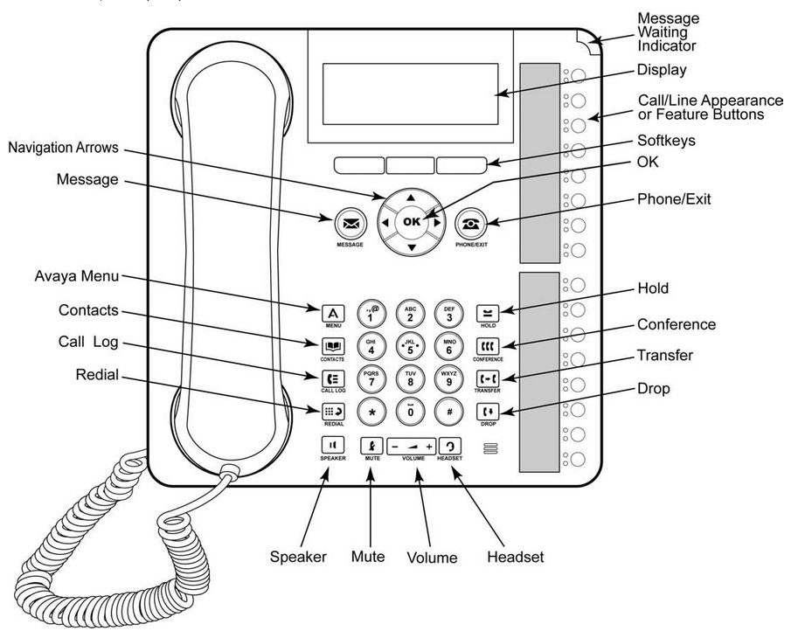
Making Calls  Exactly the same as a regular, household phone. Simply lift the handset and dial the number. There is no need to dial ‘0’ to get a line out.  Answering Calls  Lift the handset and the call will be answered. To utilize the hands-free function of the phones, simply press the SPEAKER key.  Transferring Calls  Press the TRANSFER key. The current call will automatically be placed on hold. Dial the number to which you want to transfer the call. Alternatively press the shortcut key to the desired extension.  To complete the transfer, press the TRANSFER key while the call is still ringing or after it has been answered.  Parking Calls  An alternative way of transferring calls is by utilizing the ‘Call Park’ feature keys which have been pre-programmed on all your handsets. To park a call press one of the desired park keys (these will be labeled ‘Park 1, Park 2, Park 3’, etc.). The corresponding button will then light up green on all other handsets. To pick up the call just press this button, followed by the soft key located near the LCD display to answer the call. |  | Voicemail  If VM is enabled the simplest way to access it is via the programmed ‘Voicemail’ feature key located in the bottom right corner of the phone. It’s just a case of following the prompts to listen and delete messages, edit your greeting etc. (much the same as the Telstra 101 service).  Alternatively you can use the MESSAGE key. It’s a bit more in-depth but will give you a more streamlined method of accessing your messages. For more information on this, please refer to the Avaya Mailbox User Guide.  Night Switch  If night switching is enabled, a ‘Night Switch’ button will already have been pre-programmed onto your main phone (usually Ext 200). To enable night switching, simply press this button. A green light will then appear indicating that night switching has been enabled. Please Note: This is a manual function so forgetting to turn this off will result in all calls being diverted to voicemail.  Contacts  You can add up to 100 directory contacts. Press the CONTACTS key. Use the < Left and > Right arrow keys to select your Personal directory. To add a contact, press ‘New’. To edit a contact, highlight the contact and press ‘Edit’.  Use the ^ and ˅ arrow keys to switch between number and name entries.  After you enter the required name and number, press ‘Save’.

